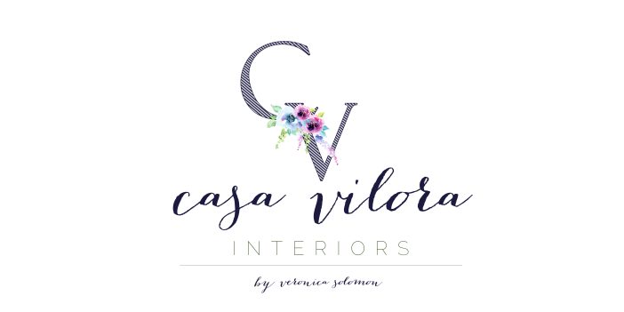
Date:
Project Name: Address:
Start Date: ____________________________ Completion Date: ___________________________

ROOM | PAINT BRAND | COLOR NUMBER | COLOR NAME | FINISH

NOTES:

By signing this paint verification form, you acknowledge that, due to varied conditions of lighting, wall finishes and other factors, colors may not be a true representation of how they appear on the swatches. These color swatches are supplied by paint companies to provide a visual guideline for each color, and may not represent an exact match of color and finish. Casa Vilora Interiors cannot be held responsible for such variations. We strongly recommend purchasing samples and testing on all samples on several walls, in several lighting conditions to make sure you like the colors specified above. Please do not have the paint colors mixed by another paint company other than the one specified. The colors will not match.
Approved by: ______________________________________________ Date: __________________
Paint Contractor: ___________________________________________ Date: __________________

